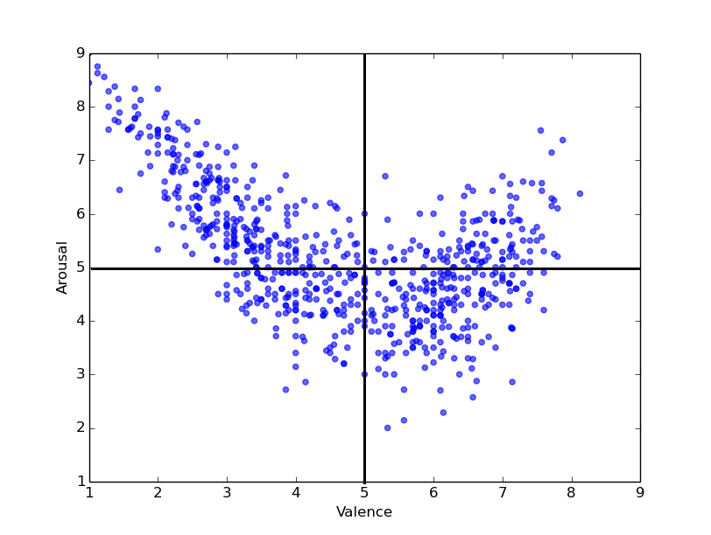

**原圖**

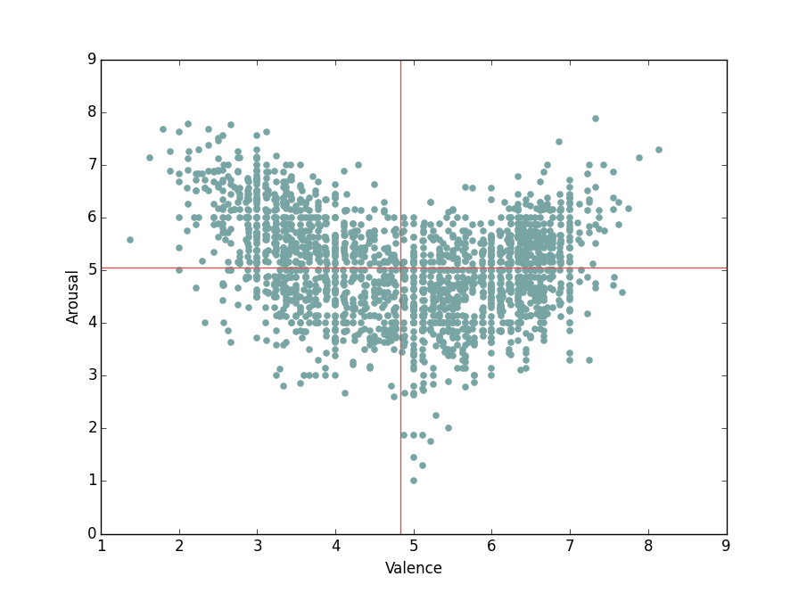

**更新後的圖**

|  |  |  |  |  |  |  |  |  |  |
| --- | --- | --- | --- | --- | --- | --- | --- | --- | --- |
|  | Num. of texts | Num. of tokens | Avg. tokens | Valence | | | Arousal | | |
| MAE | RMSE | *r* | MAE | RMSE | *r* |
| ANEW vs Forum | 20 | 15,035 | 751.75 | 1.20 | 1.55 | 0.77 | 0.72 | 0.85 | 0.27 |
| CVAW vs CVAT | 720 | 196,542 | 272.98 | 0.99 | 1.22 | 0.62 | 0.70 | 0.87 | 0.32 |
| Book Review | 105 (15%) | 16,062 | 152.97 | **0.58** | **0.73** | 0.57 | 0.68 | 0.87 | 0.13 |
| Car Forum | 164 (23%) | 24,269 | 147.98 | 1.09 | 1.31 | 0.30 | 0.66 | **0.81** | 0.21 |
| Computer Review | 112 (16%) | 14,505 | 129.51 | 0.67 | 0.90 | 0.39 | 0.77 | 0.92 | 0.30 |
| Hotel Review | 123 (17%) | 17,391 | 141.39 | 1.25 | 1.49 | 0.64 | 0.70 | 0.89 | 0.33 |
| News Article | 119 (17%) | 82,457 | 692.92 | 1.02 | 1.19 | **0.82** | **0.64** | **0.81** | 0.30 |
| Politics Forum | 97 (13%) | 41,858 | 431.53 | 1.24 | 1.44 | 0.57 | 0.81 | 0.97 | **0.41** |

**原始資料**

|  |  |  |  |  |  |  |  |  |  |
| --- | --- | --- | --- | --- | --- | --- | --- | --- | --- |
|  | Num. of texts | Num. of tokens | Avg. tokens | Valence | | | Arousal | | |
| MAE | RMSE | *r* | MAE | RMSE | *r* |
| ANEW vs Forum | 20 | 15,035 | 751.75 | 1.20 | 1.55 | 0.77 | 0.72 | 0.85 | 0.27 |
| CVAW vs CVAT | 2,009 | 32.27 | 64,826 | 1.388 | 0.961 | 0.544 | 0.791 | 0.723 | 0.219 |
| Book Review | 287 | 26.20 | 7,520 | 1.023 | 0.862 | 0.398 | 0.559 | 0.624 | 0.256 |
| Car Forum | 257 | 45.60 | 11,720 | 1.039 | 0.821 | 0.396 | 0.766 | 0.692 | 0.083 |
| Computer Review | 183 | 26.49 | 4,847 | 1.427 | 0.958 | 0.550 | 1.900 | 1.060 | 0.051 |
| Hotel Review | 301 | 21.93 | 6,601 | 2.095 | 1.251 | 0.605 | 0.981 | 0.815 | 0.291 |
| News Article | 542 | 36.75 | 19,919 | 1.243 | 0.904 | 0.645 | 0.709 | 0.680 | 0.205 |
| Politics Forum | 439 | 32.39 | 14,219 | 1.017 | 0.816 | 0.524 | 0.854 | 0.760 | 0.290 |

**更新後的資料**